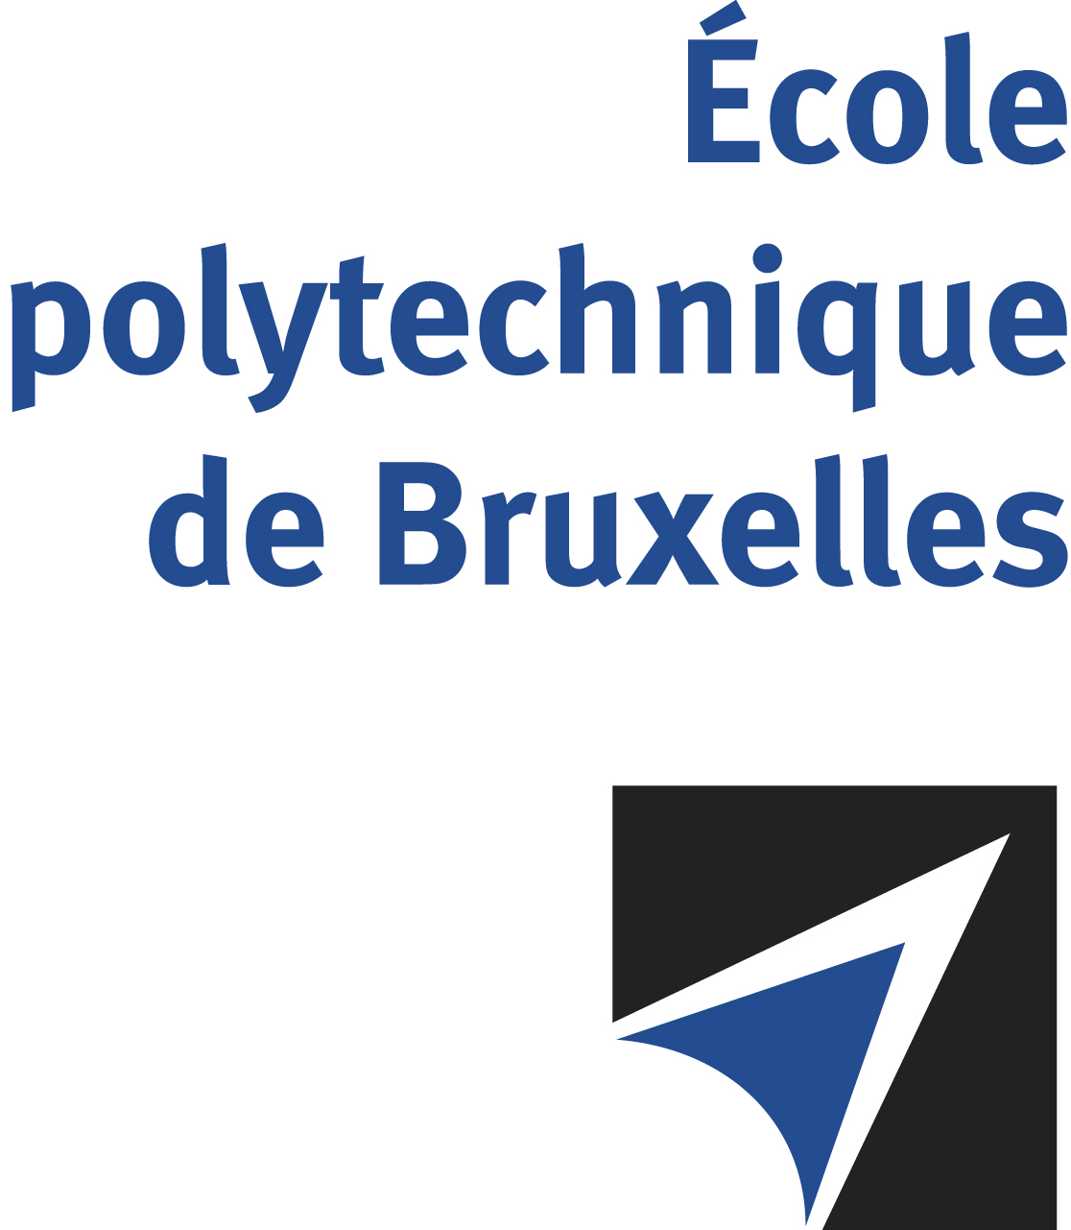

The public defense to obtain the academic degree
of Doctor in Engineering Sciences and Technology
of

Cédric HANNOTIER

will be held on

THURSDAY APRIL 24, 2025, AT 4:30PM
Solbosch Campus
Building B, Room: B1.315

The defense will also be held on Teams: https://eur01.safelinks.protection.outlook.com/?url=https%3A%2F%2Fteams.microsoft.com%2Fmeet%2F394180775133%3Fp%3Dq4tW35jv4DoOIiBlUj&data=05%7C02%7CLucyna.Mudyn%40ulb.be%7C43c44fe344cf404d164c08dd7793afeb%7C30a5145e75bd4212bb028ff9c0ea4ae9%7C0%7C0%7C638798198379468560%7CUnknown%7CTWFpbGZsb3d8eyJFbXB0eU1hcGkiOnRydWUsIlYiOiIwLjAuMDAwMCIsIlAiOiJXaW4zMiIsIkFOIjoiTWFpbCIsIldUIjoyfQ%3D%3D%7C0%7C%7C%7C&sdata=O8vg2IbmzB3h7QhuP085Y1o%2BZRryIEMwISSPR8BH5so%3D&reserved=0

Mr Cédric HANNOTIER

will present and defend in public an original thesis entitled:

Experimental-driven algorithms for time-based localization
in roadside wireless networks

Thesis director: François QUITIN
Department: BEAMS

