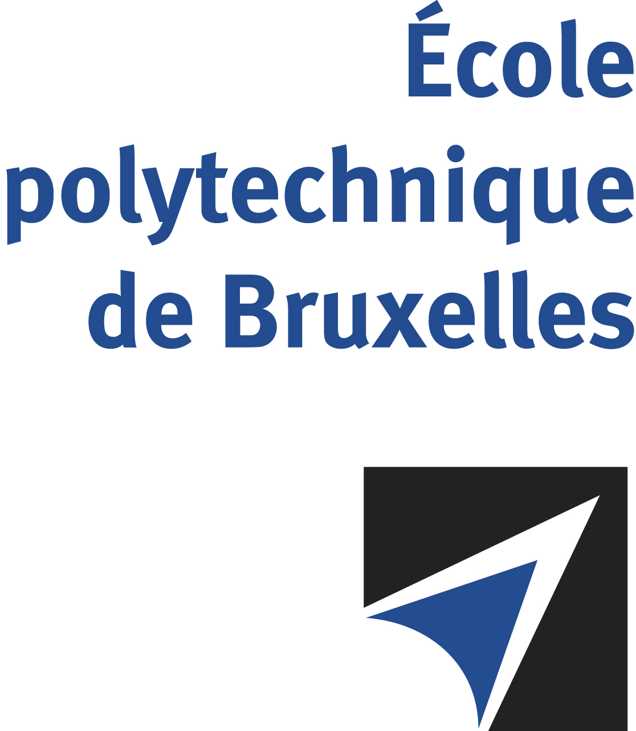

JOINT SUPERVISION
Université libre de Bruxelles - University of Pisa

The public defense to obtain the academic degree
of Doctor in Engineering Sciences and Technology

of

Laura DONATO
Nico Joan BOTEY i BASSOLS las POULVELLARIE
will be held on
THURSDAY AUGUST 28, 2025, AT 3PM
Solbosch Campus
Building B, Room: B1.315

The defense will also be held on Teams: https://teams.microsoft.com/l/meetup-join/19%3ameeting_NThiOTE2ZGYtYTNiYS00MjhhLTk1ZmUtYTg4M2NmNTRmMWVk%40thread.v2/0?context=%7b%22Tid%22%3a%2230a5145e-75bd-4212-bb02-8ff9c0ea4ae9%22%2c%22Oid%22%3a%2297b3aa39-2c3e-4337-bb1b-30904cdd59a9%22%7d
Ms Laura DONATO

will present and defend in public an original thesis entitled:

Data assimilation for the development of lifelong learning
digital twins of combustion systems

Thesis director: Alessandro PARENTE
University of Pisa thesis director: Chiara GALLETTI
Department: ATM

