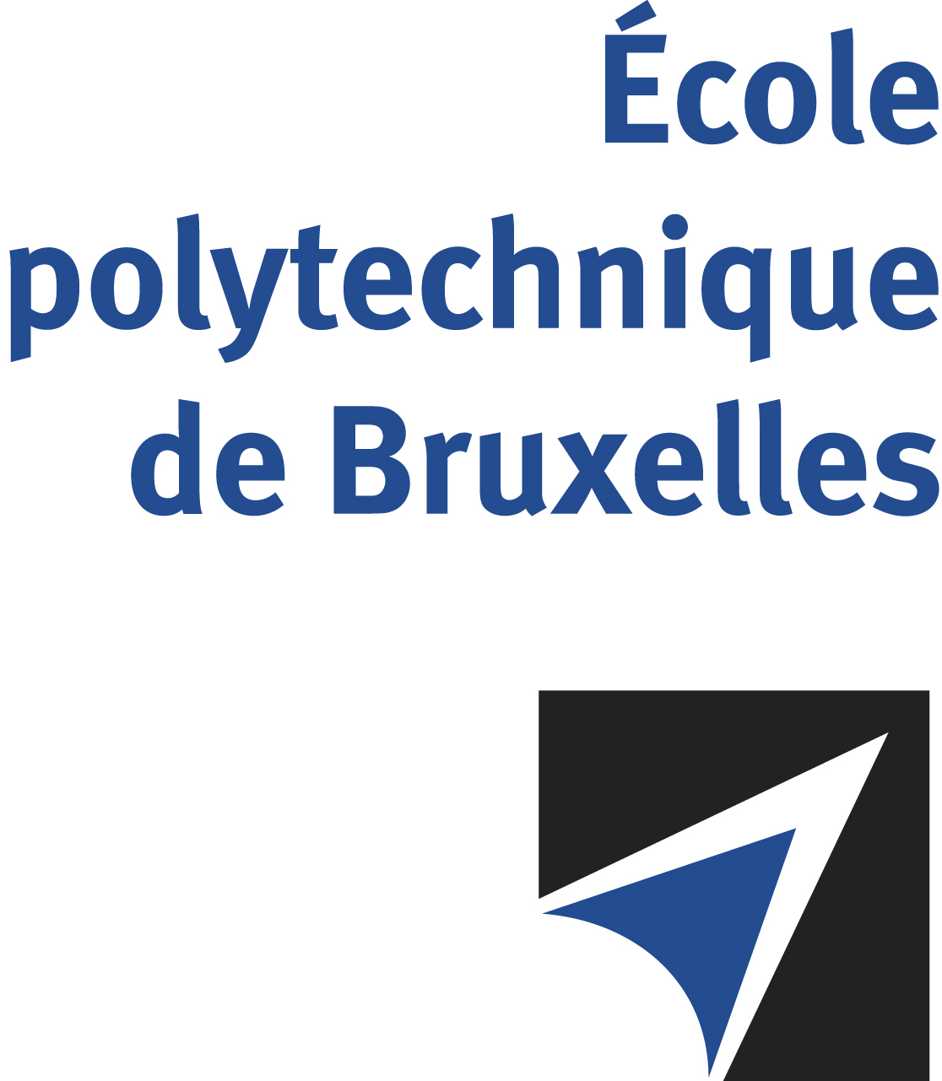

The public defense to obtain the academic degree
of Doctor in Engineering Sciences and Technology
of

Lionel DELCHAMBRE

will be held on

TUESDAY MAY 13, 2025, AT 5PM
Solbosch Campus
Building R42, 5th floor
Room: R42.5.503

The defense will also be held on Teams: https://teams.microsoft.com/l/meetup-join/19%3ameeting_ODI5NDAzNjgtZDAxNS00MjEzLTljNmUtYjI4ZTQ3ZmM5OWZj%40thread.v2/0?context=%7b%22Tid%22%3a%2230a5145e-75bd-4212-bb02-8ff9c0ea4ae9%22%2c%22Oid%22%3a%22cae1179a-8404-467b-96e4-6dc60cb864b7%22%7d

Mr Lionel DELCHAMBRE

will present and defend in public an original thesis entitled:

Development of innovative solutions for leveraging grid-safe LV flexibility

Thesis director: Patrick HENDRICK
Thesis co-director: Pierre HENNEAUX
Department: ATM

