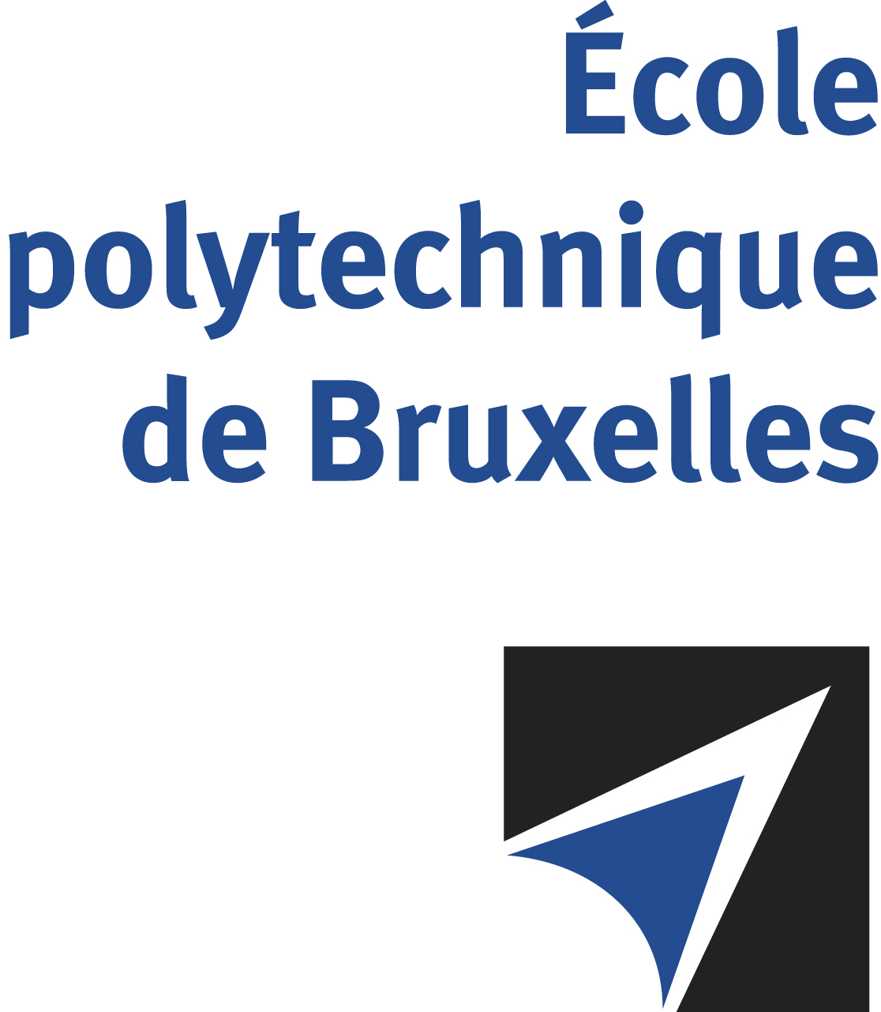

JOINT SUPERVISION
Université libre de Bruxelles - Masaryk University

The public defense to obtain the academic degree
of Doctor in Engineering Sciences and Technology

of

Matúš CHVOJKA
Nico Joan BOTEY i BASSOLS las POULVELLARIE
will be held on
THURSDAY MAY 15, 2025, AT 3PM
Room B17-432, University Campus Bohunice, Brno

The defense will also be held on Teams: https://teams.microsoft.com/meet/374292601931?p=514yGkNSu1pnDGN1aP
Mr Matúš CHVOJKA

will present and defend in public an original thesis entitled:

Fluorinated bambusurils as anion receptors and transmembrane transporters

Thesis director: Hennie VALKENIER
MU thesis co-director: Vladimír ŠINDELÁŘ
Department: Engineering of Molecular NanoSystems (EMNS)

