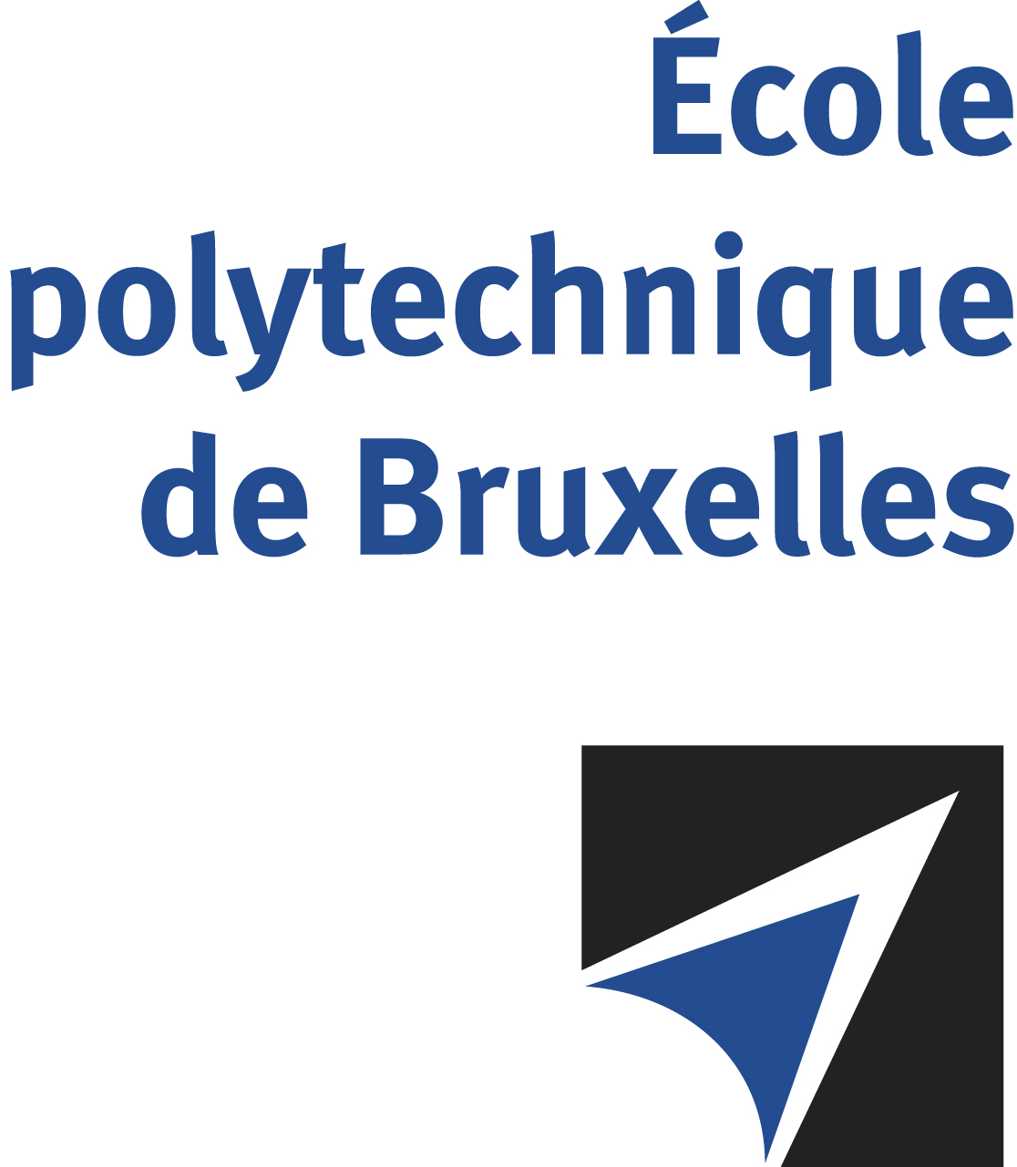

The public defense to obtain the academic degree
of Doctor in Engineering Sciences and Technology
of

Mohamed NAEIM

will be held on

THURSDAY AUGUST 28, 2025, AT 4PM
Solbosch Campus
Building D, Room: DC2.206

The defense will also be held on Teams: Join the meeting now
Meeting ID: 333 477 629 686 2 Passcode: Sy2jE9ds
Mr Mohamed NAEIM

will present and defend in public an original thesis entitled:

Design enablement & system level characterization of sub-2nm CMOS nodes and 3D multi-die package integration

Thesis director: Dragomir MILOJEVIC
Department: BEAMS

