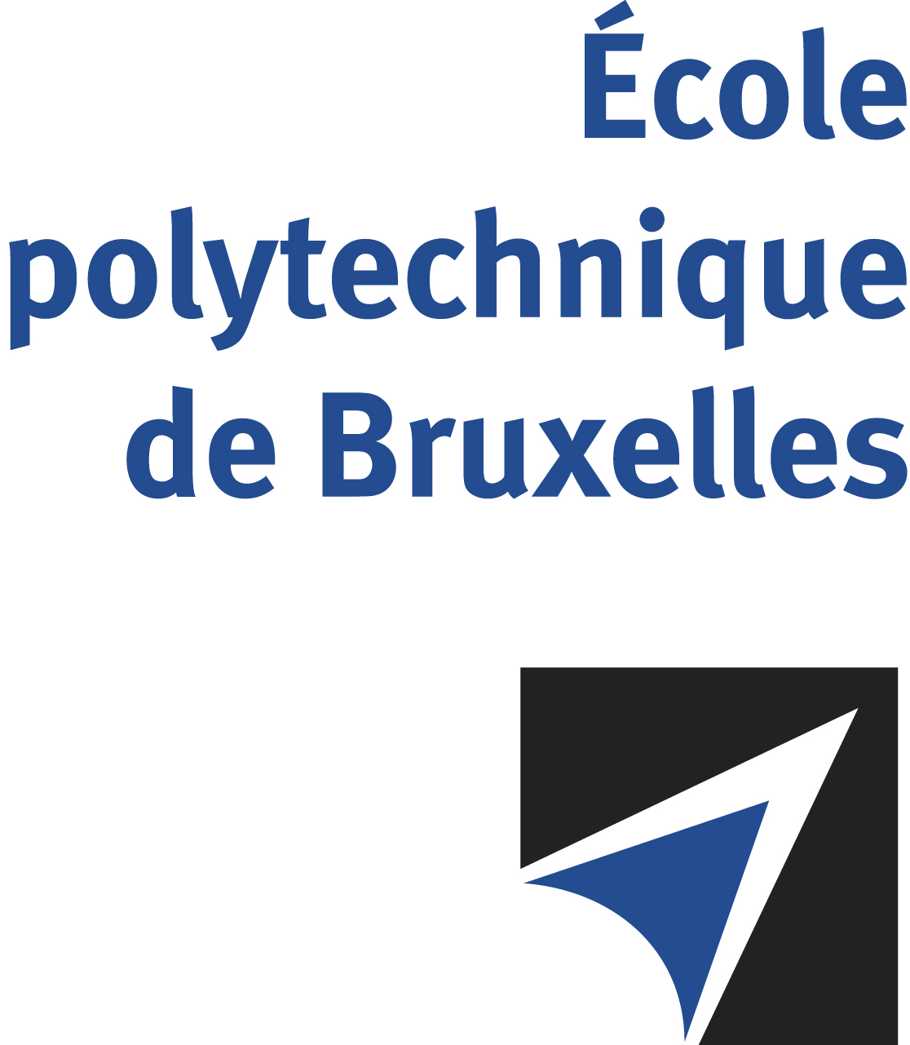

JOINT SUPERVISION
Université libre de Bruxelles - Eindhoven University of Technology

The public defense to obtain the academic degree
of Doctor in Engineering Sciences and Technology

of

Nikhil DAVE
Nico Joan BOTEY i BASSOLS las POULVELLARIE
will be held on
MONDAY MAY 12, 2025, AT 1:30PM
Eindhoven University of Technology
La salle Atlas.0.710 (building 3)

The defense will also be held on Teams: https://tinyurl.com/4dw9f4rb
Mr Nikhil DAVE

will present and defend in public an original thesis entitled:

Multiscale modelling of dimensional stability and through-thickness liquid transport in paper sheets

Thesis director: Thierry J. MASSART
TU/e Eindhoven thesis director: Marc G.D. GEERS
TU/e Eindhoven thesis co-director: Ron H.J. PEERLINGS
Department: BATir

